School Council Competition
Create a potato character!
World Book Day
Tuesday 5th March 2024
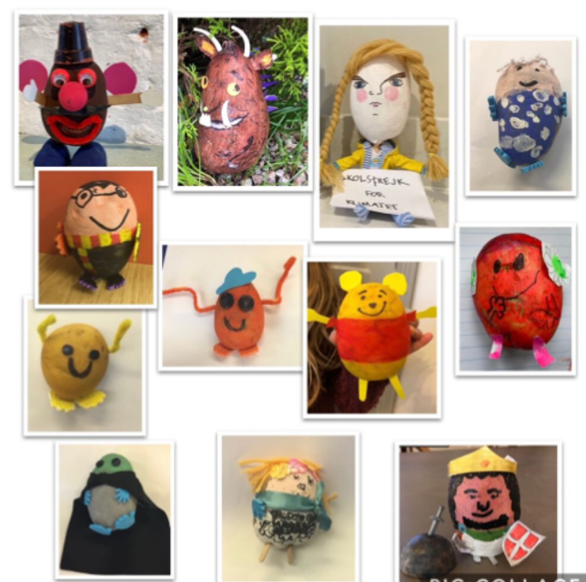

They will be displayed for everyone to see and in the afternoon you can vote for who you think should win.
There will be one winner from each year group and a prize of book tokens.
Have fun getting creative!

