
COMPUTING: PROGRAMMING- Events and Actions
KNOWLEDGE ORGANISER
Y3

Overview |  |  | Event and Action Blocks
Events and Actions in Scratch  - Programming is when we make a set of instructions for computers to follow.  -Scratch is a program that we can use in order to code our own stories and animations. We can use event and action command blocks in order to make sprites carry out acts when certain prompts take place.  -We use algorithms (a set of instructions to p  erform a task) to sequence movements, actions and sounds in order to program effective animations.  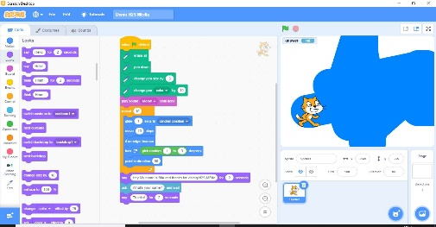  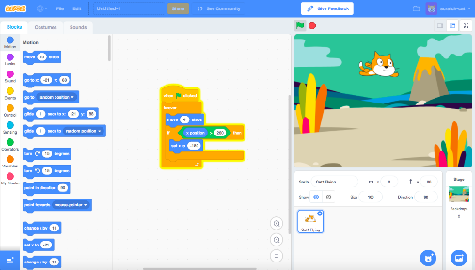 |  |  | 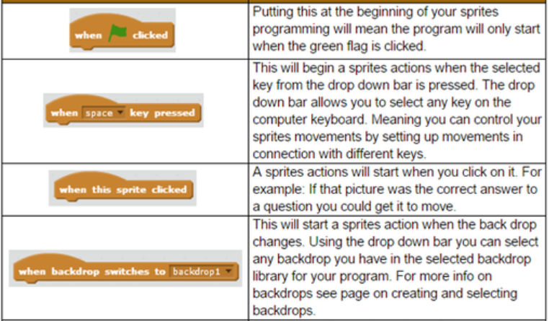  -Event Blocks: Event blocks are coloured yellow and are used to sense different events that happen, e.g. the green flag being clicked, when a key is pressed, or when a sprite is pressed. They are needed for every project.  -Action Blocks: Action blocks include ‘Motion’ blocks (coloured blue), ‘Sound’ blocks (pink) and ‘Looks’ blocks (purple). They make the sprite move, make sounds and change appearance when the event is triggered.  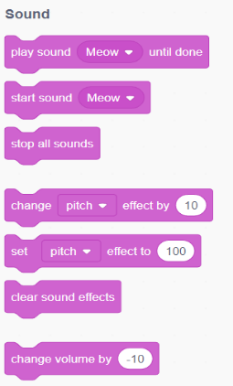  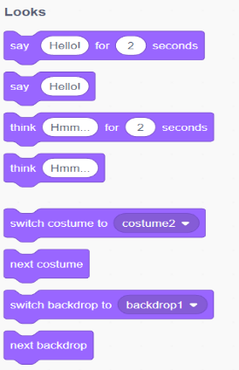  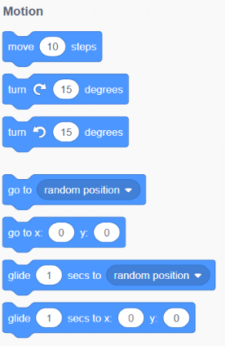
The Basics of Scratch
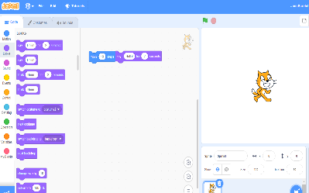
-What is Scratch? Scratch is a website/ app that lets us code our own stories, games and animations.

-Scratch helps us to learn how to use programming language, whilst also being creative and using problem-solving skills.
 |  |  | Sequencing and Algorithms | Trialling and Debugging
 |  |  | -A sequence is a pattern or process in which one thing follows another. In Scratch, blocks can stack vertically on top of one another to create sequences.  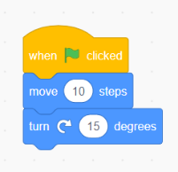  -Designing an algorithm (set of instructions for performing a task) will help you to program the sequence that you require.  -Programming is when we move the blocks into the position (based on our algorithm design). Programming uses a code that the computer can understand. | -Programmers do not put their computer programs straight to work. They trial them first to find any errors:    -Sequence errors: An instruction in the sequence is wrong or in the wrong place.  -Keying errors: Typing in the wrong code.  -Logical errors: Mistakes in plan/thinking.  -If your algorithm does not work correctly the first time, remember to debug it.
There are three main areas in Scratch:  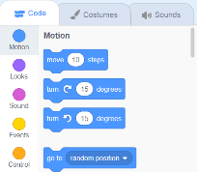  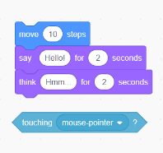  -The Blocks Palette (on the left) contain all of the different blocks: puzzle piece commands which control the animation.  -Code Area (in the middle) is where the blocks are placed to create a program.  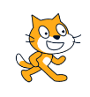  -Stage with Sprite (right) is where the output of the program is presented. The sprite is the character. | Adding/Removing Sprites: This can be done here, at the bottom of the stage. There are many sprites to choose from.  Attributes: There are three attributes of the sprite which we can change to make our animation: Code, Costumes, Sounds.    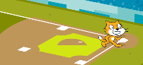  -Backdrops: Backdrops can be added by clicking on this icon (bottom right of the screen, below the stage).
Important Vocabulary

Motion Event Logic Move Resize Extension block Pen Action Errors Test

