 | Milford Primary School  Care, Share, Respect, Learn!  Chevin Road, Milford, Belper, Derbyshire, DE56 0QH  Tel: 01332 841316  Headteacher: Ms Emma Roberts  e-mail: eroberts@milford.derbyshire.sch.uk  www.milfordprimaryschool.co.uk

Reading for Pleasure at Milford Primary School

Dear Parents/Carers,

As we approach the end of term, we would like to take the opportunity to thank you for your ongoing support with your child’s reading.

At Milford, we believe that reading for pleasure is the entitlement of every child to which our pupils are given the opportunity to read for enjoyment, not simply to learn to read. We therefore work hard to provide ongoing experiences and exposure to a range of reading opportunities. We have worked hard to embed reading assemblies, outdoor reading library time, reading cafes and planned story times as a few examples, to see more please see our school website by following the link below:

https://www.milfordprimaryschool.co.uk/reading-for-pleasure/

Working together we want to maintain the buzz for reading around school. Please see below for suggestions of how to engage your child in reading for pleasure during the holidays too:
Reading Rivers  Display a journey of reading over a set time.  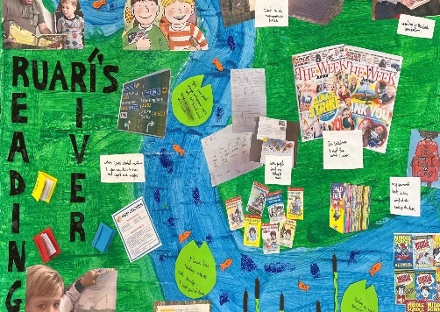 | We are going on a reading hunt!  Search the local area for reading opportunities.  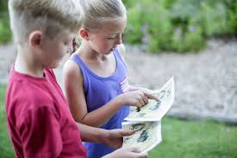 | Explore the RFP Tube Map  See the attachment for age specific maps (Paper copy sent home with your child).  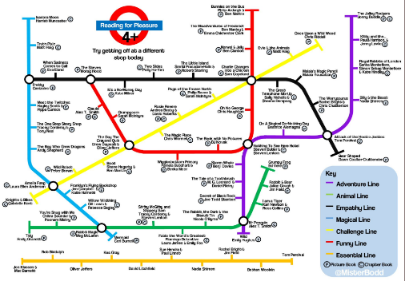

Thank you again for your ongoing support, and happy reading!

Kind regards,
Mrs R Jones
Early Reading Lead

