
COMPUTING: DATA AND INFORMATION- Introduction to Spreadsheets
KNOWLEDGE ORGANISER
Y6

Overview |  |  | What are Spreadsheets?
Spreadsheets  -Data is raw numbers and figures. Information is what we can understand from analysing data.  -There are lots of different ways that we can collect, log and interpret data, including by using spreadsheets.  -Spreadsheets organise and store data in meaningful ways so that it can be easily accessed and analysed. Computer spreadsheets are particularly useful for powerful calculations, graphs and charts.  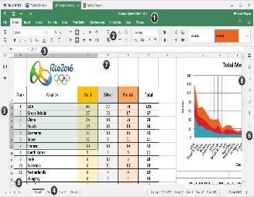  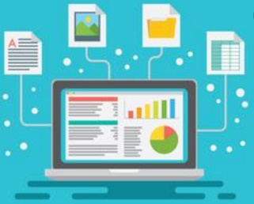 |  |  | -A spreadsheet is a computer application that allows users to organise, analyse and store data in a table. Programs such as Microsoft Excel and Google Docs help users to make spreadsheets.  -A spreadsheet can be made up of multiple worksheets. They can be reordered and renamed. Each cell has a unique reference, made up of a number (the row) and letter (the column).  -Data headings allow data to be stored in a meaningful way.  -To select a cell, we click on it. To enter data, we double click on it. Data can be typed directly into a cell or into the formula bar.  -By clicking on a column or row, we can sort information in different ways (e.g. alphabetically, 0-9, etc).  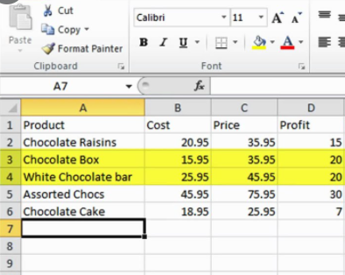  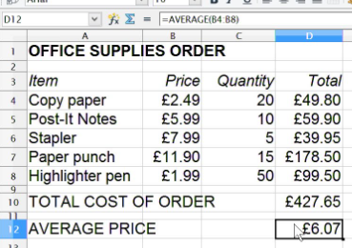
Formulas, Calculating and Duplicating
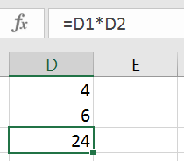
Formulas: A formula can tell a computer which mathematical operation to use for a calculation: add, multiply, divide, or subtract. It also tells the computer which data to use.
+ = add - = subtract * = multiply / = divide
Select your cell. Use cell references to create your formula.
All formulas must begin with the = sign.
E.g. In D3, you enter the formula =D1*D2. The answer will appear in D3.
 |  |  | Other Functions | Using Spreadsheets
 |  |  | -Formatting makes a spreadsheet easier to read. Hovering the mouse between two columns/ rows allows the user to drag them to the desired size. Right-clicking on a cell and selecting ‘format cells’ presents a number of options, including fonts, borders, fill etc.  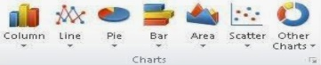  -Charts and graphs can be created using the data in the spreadsheet. Select the charts icon (see below) and which fields to display in the x-axis and y-axis. | -Spreadsheets are commonly used by individuals and businesses across the world. They are most commonly used for organising and presenting finances, for example budgets and finance reports.    -Spreadsheets may be used by businesses to look back on past income and expenditure and to forecast future performance. They are also used for calculating taxes and deductions.  - Data is often presented in tables or graphs.
  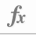  -Calculations: Sometimes there are large amounts of data that require multiple or complex sums. The ‘fx’ or ‘sigma’ icons (see below, depending on the program you are using) can help you to find averages (AVERAGE) add many cells together (SUM) and many other calculations. | -Duplicating: Duplicating allows you to create copies of the same data, without having to type it out multiple times. The copy and paste function (Ctrl+C and then Ctrl+V) can duplicate individual cells. You can duplicate whole worksheets by clicking on the worksheet name and selecting ‘move or copy’ then tick ‘create a copy.’
Important Vocabulary
Spreadsheet Data Heading Cells Data Columns and Rows Data Format Common Attribute Formula Calculation Cell Reference Operation Range Graph Chart Evaluate Results Comparison

